**Written Assignment 3**

**薛劭杰 1930026143**

Q1.

List the value and weight of each item:

|  |  |  |  |  |  |  |
| --- | --- | --- | --- | --- | --- | --- |
| $$V[i, w]$$ | 1 | 2 | 3 | 4 | 5 | 6 |
| $$v_{i}$$ | 8 | 2 | 5 | 13 | 16 | 1 |
| $$w_{i}$$ | 5 | 3 | 2 | 1 | 6 | 4 |

Firstly, for $0≤i≤6$, and $0≤w≤10$, define

$$V\left[i,w\right]=max⁡\{\sum_{j∈T}{v_{j}}:T⊆\left\{1,2,…,i\right\},\sum_{j∈T}{w_{j}}≤w\}$$

The maximum value of any subset of items $\{1,2,…,i\}$ of weight at most $w$.

And then for recursion:

$$V\left[i,w\right]=\max\left(V\left[i-1,w\right],v_{i}+V\left[i-1,w-w_{i}\right]\right) for 0≤i≤6, 0≤w≤10$$

Boundary cases:

$$\left\{\begin{aligned}V\left[0,w\right]=0 for 0≤w≤10, no item \\ V\left[i,w\right]=-∞ for w<0, i llegal\end{aligned}\right.$$ Let $W=10$ and $V\left(1,0\right)=\max\left\{V\left(0,0\right), v_{1}+V\left(0,-5\right)\right\}=\max\left\{0, -∞\right\}=0$

$V\left(1, 5\right)=\left\{V\left(0,5\right), v_{1}+V\left(0,5-5\right)\right\}=\max\left\{0,8+0\right\}=8$

$V\left(2, 3\right)=\left\{V\left(1,3\right), v_{2}+V\left(1,3-3\right)\right\}=\max\left\{0,2+0\right\}=2$

$V\left(2, 5\right)=\left\{V\left(1,5\right), v_{2}+V\left(1,5-3\right)\right\}=\max\left\{8,2 \right\}=8$

$V\left(2, 8\right)=\left\{V\left(1,8\right), v_{2}+V\left(1,8-3\right)\right\}=\max\left\{8,2+8 \right\}=10$

Same as that: $V\left(3, 2\right)=10;V\left(3,5\right)=8; V\left(3,7\right)=13;V\left(3,10\right)=15$

$V\left(4, 1\right)=13;V\left(4,3\right)=18; V\left(4,6\right)=21;V\left(4,8\right)=26$

$V\left(5,1\right)=13;V\left(5,3\right)=18; V\left(5,6\right)=21;V\left(5,7\right)=29;V(5,9)=34$

$V\left(6,1\right)=13;V\left(6,3\right)=18; V\left(6,6\right)=21;V\left(6,7\right)=29;V(6,9)=34$

|  |  |  |  |  |  |  |  |  |  |  |  |
| --- | --- | --- | --- | --- | --- | --- | --- | --- | --- | --- | --- |
| $$V[i, w]$$ | 0 | 1 | 2 | 3 | 4 | 5 | 6 | 7 | 8 | 9 | 10 |
| 0 | 0 | 0 | 0 | 0 | 0 | 0 | 0 | 0 | 0 | 0 | 0 |
| 1 | 0 | 0 | 0 | 0 | 0 | 8 | 8 | 8 | 8 | 8 | 8 |
| 2 | 0 | 0 | 0 | 2 | 2 | 8 | 8 | 8 | 10 | 10 | 10 |
| 3 | 0 | 0 | 5 | 5 | 5 | 8 | 8 | 13 | 13 | 13 | 15 |
| 4 | 0 | 13 | 13 | 18 | 18 | 18 | 21 | 21 | 26 | 26 | 26 |
| 5 | 0 | 13 | 13 | 18 | 18 | 18 | 21 | 29 | 29 | 34 | 34 |
| 6 | 0 | 13 | 13 | 18 | 18 | 18 | 21 | 29 | 29 | 34 | 34 |

For $V\left(6,10\right)=\max\left\{V\left(5,10\right),v_{6}+V\left(5,6\right)\right\},V\left(5,10\right)>v_{6}+V\left(5,6\right)→so keep\left(6,10\right)$

$For V\left(5,10\right)=\max\left\{V\left(4,10\right),v_{5}+V\left(4,4\right)\right\},V\left(4,10\right)<v_{5}+V\left(4,4\right)→so keep(6,10)=1$

$For V\left(4,4\right)=\max\left\{V\left(3,4\right),v_{4}+V\left(3,3\right)\right\},V\left(3,4\right)<v_{4}+V\left(3,3\right)→keep(4,4)=1$

For $V\left(3,3\right)=\max\left\{V\left(2,3\right),v_{3}+V\left(2,1\right)\right\},V\left(2,3\right)<v_{3}+V\left(2,1\right)→ keep\left(3,3\right)=1$

For $V\left(2,1\right)=\max\left\{V\left(1,1\right),v_{2}+V\left(1,-2\right)\right\},V\left(1,1\right)>v_{2}+V\left(1,-2\right)→ keep(2,1)=0$

For $V\left(1,1\right)=\max\left\{V\left(0,1\right),v_{2}+V\left(0,-4\right)\right\},V\left(0,1\right)>v_{1}+V\left(0,-4\right)→ keep(1,1)=0$

To conclude, the optimal value is $16+13+5=34$ and the optimal itemset is $3,4,5$.

Q2.

For the optimal multiplication sequence, at the last step we should multiply two matrices and minimize the number of $A_{i..j}=\left(A_{i}…A_{k}\right)\left(A_{k+1}…A_{j}\right)=A_{i…k}A_{k+1…j}$. And we can get this question to those of its subproblems. The cost can be described by the following recursion:

$m\left[i,j\right]=\left\{\begin{aligned}0 i=j, \\ \min_{i≤k<j}{(m\left[i,k\right]+m\left[k+1,j\right]+p_{i-1}p_{k}p_{j}} i<j\end{aligned}\right.$ which m is represented to the $\left(A_{i}…A_{k}\right)\left(A_{k+1}…A_{j}\right)$. Then bottom-up computation of $m[i,j]$

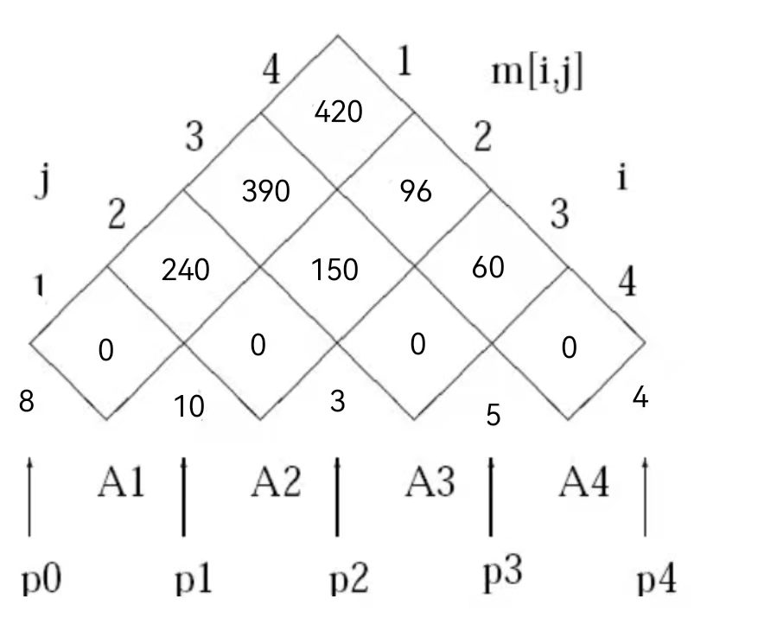

396

180

360

sas

sas

360

sas

$m\left[1,2\right]=m\left[1,1\right]+m\left[2,2\right]+p_{0}p_{1}p_{2}=240, k=1$

$m\left[2,3\right]=m\left[2,2\right]+m\left[3,3\right]+p_{1}p_{2}p_{3}=150, k=2$

$m\left[3,4\right]=m\left[3,3\right]+m\left[4,4\right]+p_{2}p_{3}p_{4}=60, k=3$

$m\left[1,3\right]=min⁡(m\left[1,1\right]+m\left[2,3\right]+p_{0}p_{1}p_{3},m\left[1,2\right]+m\left[3,3\right]+p_{0}p_{2}p_{3})=360, k=2$

$m\left[2,4\right]=min⁡(m\left[2,2\right]+m\left[3,4\right]+p_{1}p_{2}p_{4},m\left[2,3\right]+m\left[4,4\right]+p_{1}p_{3}p_{4})=180, k=2$

$m\left[1,4\right]=\min\left(m\left[1,1\right]+m\left[2,4\right]+p_{0}p_{1}p_{4},m\left[1,2\right]+m\left[3,4\right]+p_{0}p_{2}p_{4}, m\left[1,3\right]+m\left[4,4\right]+p_{0}p_{3}p_{4}\right)=\min\left(180+320, 240+60+96,360+160\right)=396, k=2.$

$m\left[1,4\right]→396, k=2, so we can obtain optimal solution \left(A_{1}A_{2}\right)\left(A_{3}A_{4}\right).$

Q3.

Using dynamic programming, we record each optimal solution in a matrix with time for time。

Step1: Create a matrix with identical shape with two strings and initialization it.

Step2: Traversal matrix (two-dimensional array).

$-Case 1:if the item in row and columns is same then position will be d\left[i-1\right]\left[j-1\right]+1$. (In this way it can record the best case in subproblem).

$-Case 2:if the item in row and columns is different then position will get 0$.

Step3: Record the largest number each time during the traversal process.

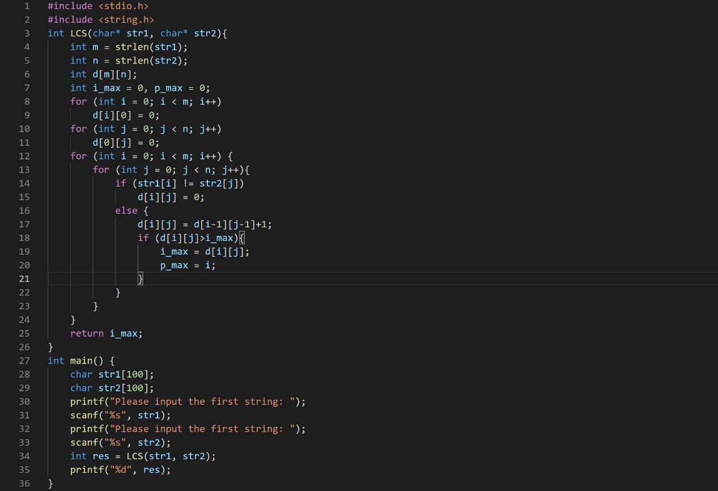

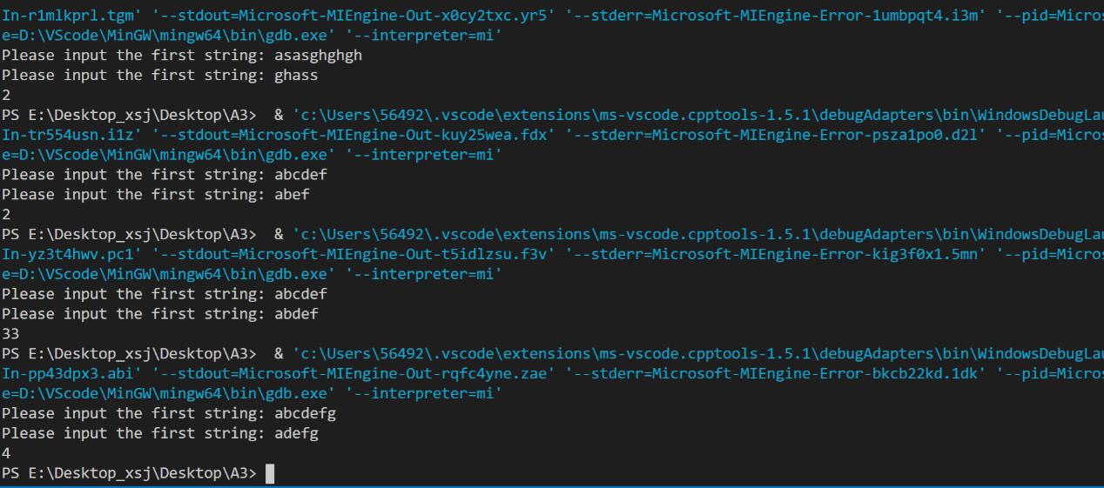

Q4.

Using dynamic programming, we record each optimal solution in a matrix with time for time。

Step1: Create a matrix with identical shape with $length+1$ two strings and initialization it.

Step2: Traverse the two-dimensional matrix, and there two cases:

$-Case 1:if the item in row and columns is same, then position will be d\left[i-1\right]\left[j-1\right]+1$.

$$-Case 2:if the item in row and columns is different then position will get the maximum$$

$of Above or to its left$, $so$ every time it can get the best solutions.

Step3: Return the last number after traversing and it is just the max one.

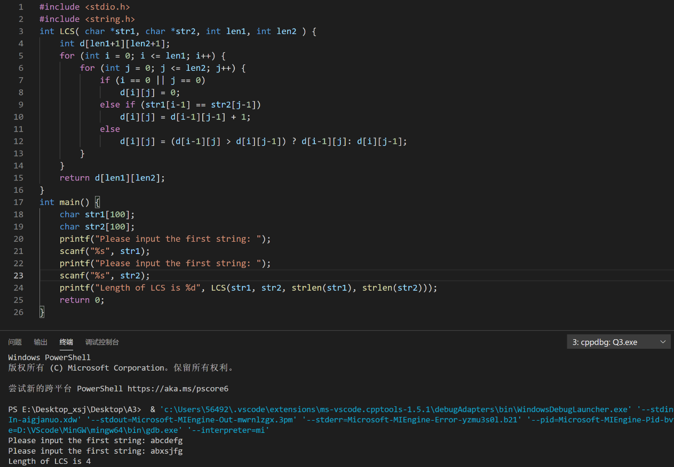

Q5.

Firstly, we can count all of the frequency of letters:

|  |  |  |  |  |
| --- | --- | --- | --- | --- |
| alphabet | $$a$$ | $$b$$ | $$c$$ | $$d$$ |
| $$Frequency$$ | $$5$$ | $$4$$ | $$8$$ | $$3$$ |

In the fixed-length binary code:

$a:00, b=01, c=10, d=11$, and required $\left(5+4+8+3\right)*2=40$ bits to store the file.

In the variable-length binary code:

Using greedy algorithm for Huffman Coding:

* Step1: Choose the smallest two letter and build the tree ($d:3, b:4$)

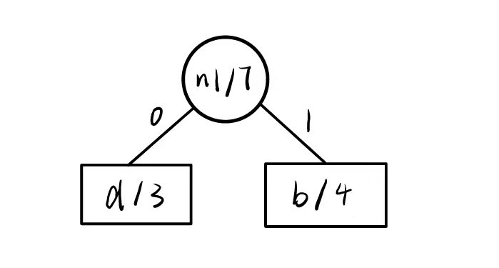

* Step2: Continue to choose the smallest two items and merge to the tree ($a:5, n1:7$)

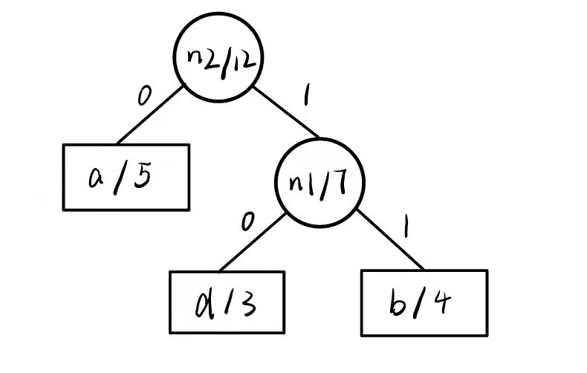

* Step3: Merge the last one alphabet $"c"$ to the Huffman tree ($c=8, n2:12$)

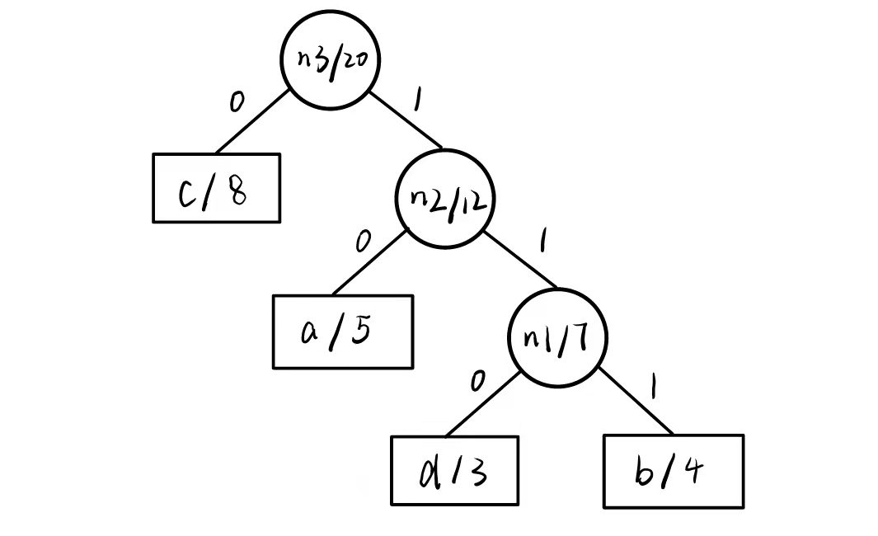

The left edge connection is 0 and right is 1. The Huffman code is $c=0, a=10, d=110. b=111$. This coding method required $8*1+5*2+3*3+3*3=39$ bits to store the file.